1.6 Brown Book

Page 126 #15, 17, 19, 33, 39, 49-69odds

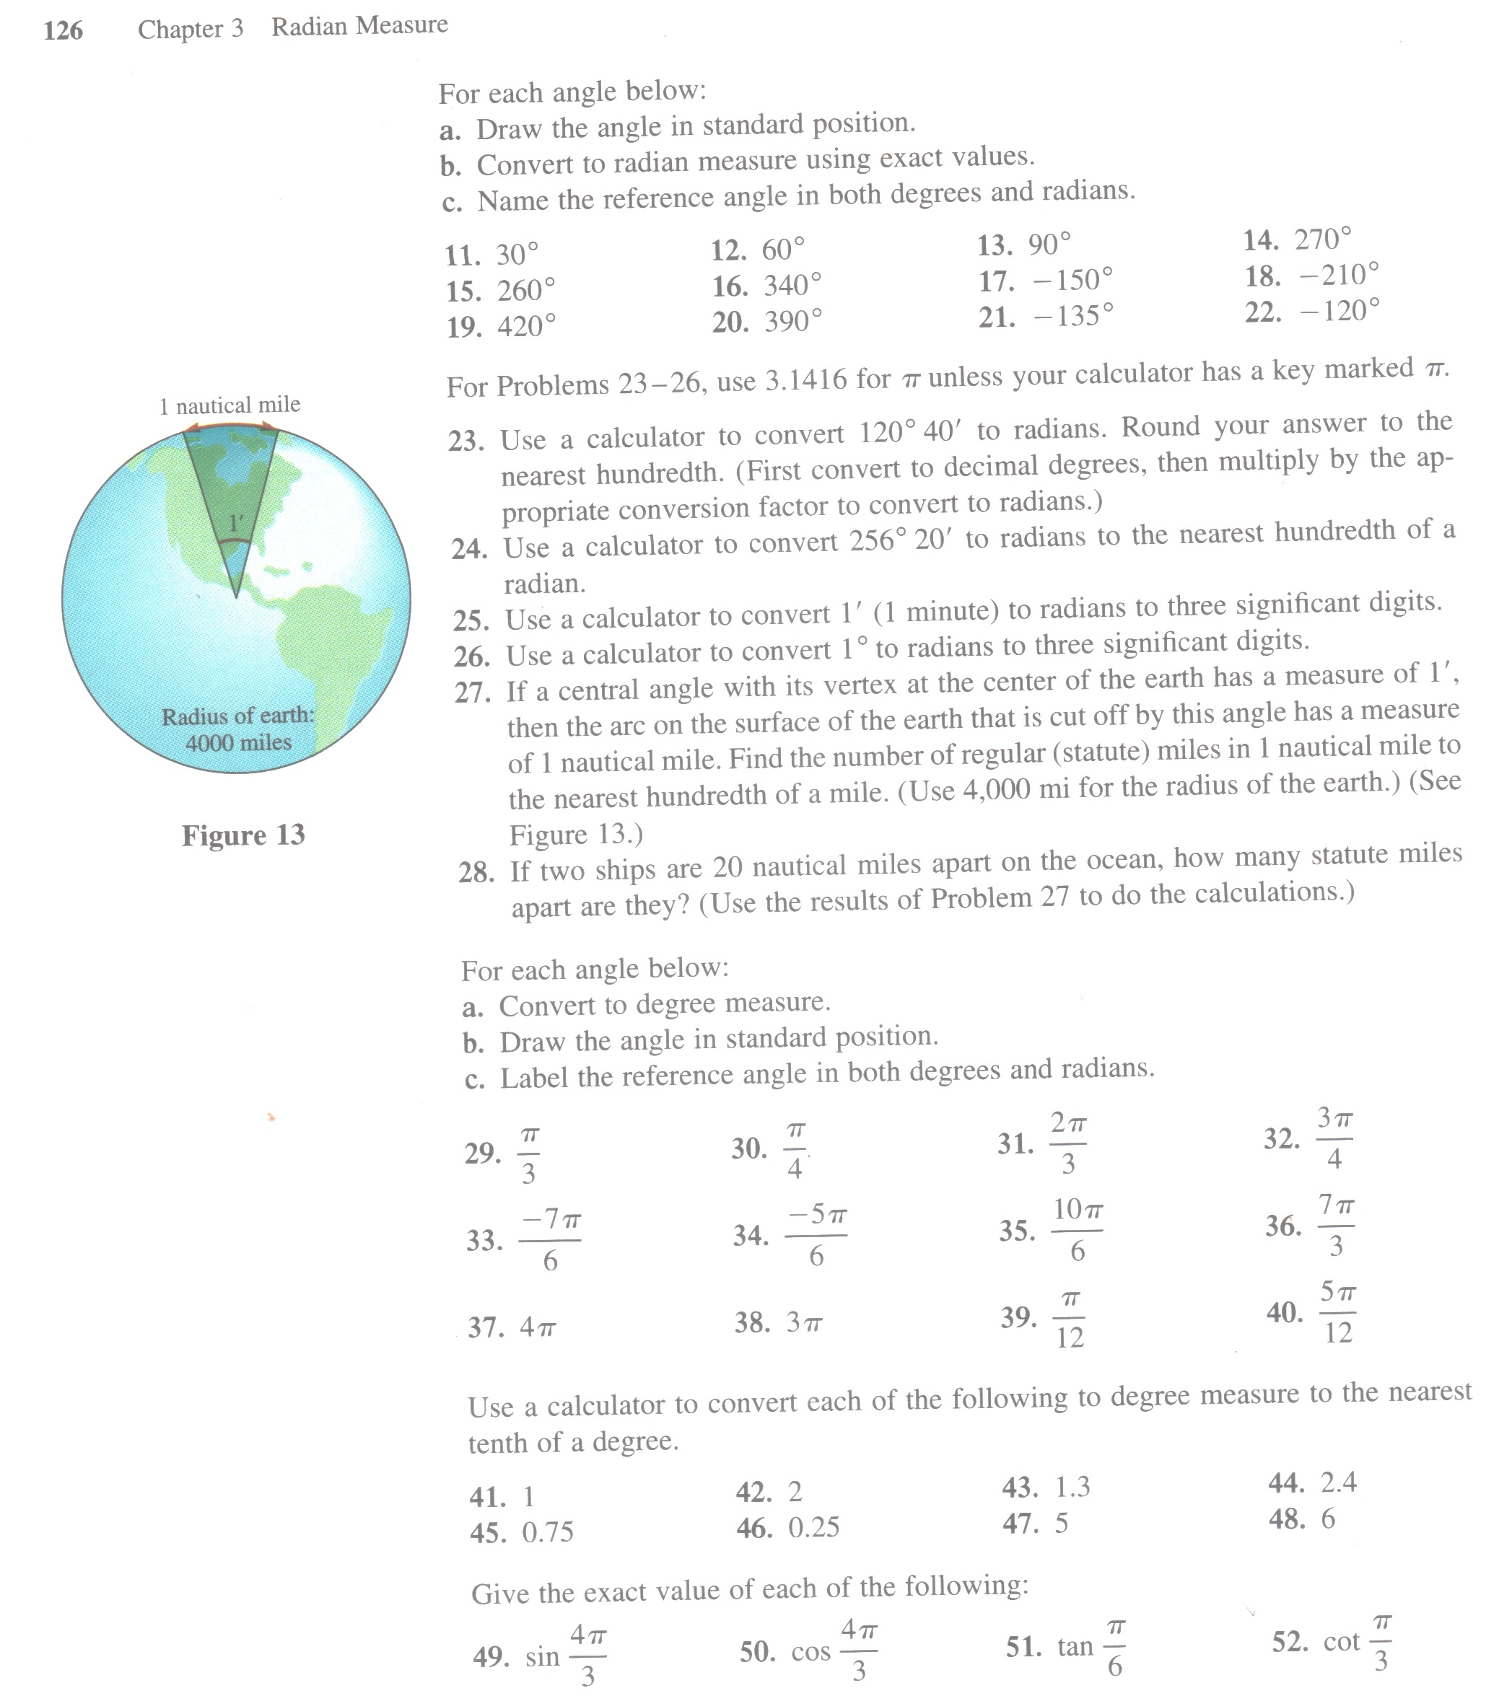
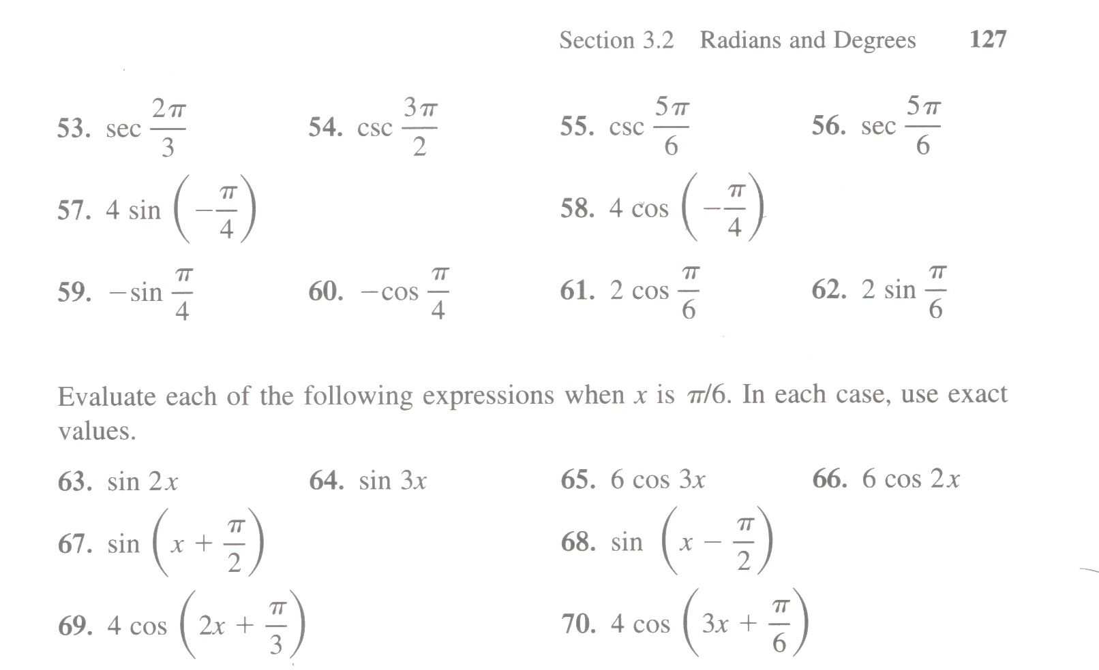

Pg 144 #43, 45, 49

